GLOVE DESIGN RESEARCH
Name
Institution Affiliation
Date

Summary –Glove Making
There is a wide gap that the ordinary glove has left over industries and this has been a huge detriment. The focus of our research is to design a glove that fills most gaps that have been left out, such as cerebral palsy situations. Glove is known for its power to aid in gripping. Various situations have presented themselves posing a variety of persons facing a challenge when it comes to what their hands can hold. A good example would be people suffering from cerebral palsy who face challenges with controlling their hands. The main objective of this paper is to present a summary of our design in comparison to what we found after conducting the research, the available designs of making gloves and raise questions of concern in area of interest as well as mentioning what we did not find during the exercise.
When it comes to designing the gloves, several requirements should be taken into consideration the main purpose being to curb the problem. Some of prime ones include: whether the user is able to grip things with the glove; the maximum amount of weight one can grip; how user friendly the glove is; how heavy the glove will be to the user; how flexible and comfortable the glove will be and; level of accuracy in detecting the time that a user wants to grip. Let’s look at the design.
Design
Our glove will be designed by solid works. We have pursued on how we will make it fit and have the feeling of flexibility. We reviewed two main design areas, Bowden cables and pneumatic designs. Cables will be of importance for they are cheap and simple to use. We will use variable motors to support varied forces. Our value proposition - we consider individual control as opposed to linear actuators. One way to measure the ability of the patient to grip is using electromyography (EMG) which measures the potential of the muscle cells on the forearm near the wrist. Using this primary merit of the design, the ability to monitor electrical signals from patient’s brain to the forearm is pursued. The signals can also be separated from the body of the glove avoiding contact between water and the signals. The only demerit of EMG is the fact that it makes noise that would in turn cause discomfort.
Another design is the use of a button to activate this glove. It is easy to implement which would be preferred by many although it poses difficulties when patients lack both hands. Its suitability would also be disregarded when patient is extremely weak lacking the strength to press the button.
Technology advancements has enabled many designs to use additional sensors at fingertips patient’s to provide feedback on the gripping force achieved by the glove. These gives control on the amount of force to be put so as to avoid hurting the patient by putting too much force.Ballon sensors also exist which have a tube made of rubber meant to close at the end and connect to a pressure sensor which creates pressure in the inside. Capacitive force sensors can also be used to provide feedback only they are limited for requiring presence of electrical components in the hand of the patient.
Design overview
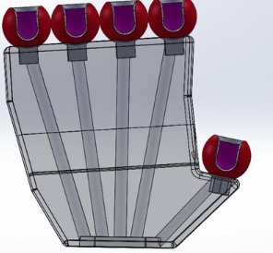
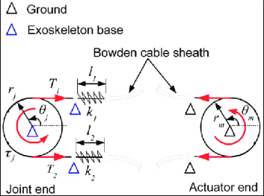
Linear actuators, pumps, compressors and servomotors are some of the methods used for generating gripping force required for objects not forgetting the transmission force method is the major determinant of the method of force generation. Hollow cables or coatings surrounding cables can also be used to transmit the forces of pushing and pulling which are the most suitable solution to this problem taking available resources into consideration. However, Exo glove poly is the design that we choose which is waterproof and made of silicon. Solid works is what we are planning to use to protect hands from electrical sensors.
Agreements were made on how this design will be actualised and used at the end of the discussion. How to develop the design is what is yet to be determined and is the purpose of this project which will be achieved with the help of the researchers who gave us ideas and shared their personal experiences on how gloves are made.
A major area of concern or question that erupted was in the event where both hands are amputated. What should the design look, how should it be customized to address that problem. Robots cannot effective act in the place of a human mind and that is why there is the need for an advanced glove.

References:
BioroboticsSNU. “Exo-Glove Poly (Extended) (Seoul National University).” YouTube, YouTube, 15 Feb. 2016, www.youtube.com/watch?v=oNEFXcWRIG8&t=7s.
“GM-NASA Space Robot Power Glove.” YouTube, YouTube, 6 July 2016, www.youtube.com/watch?v=fysTNoLT3FA.
“Power Assist Glove - Flexion Greb.” YouTube, YouTube, 2 Apr. 2015, www.youtube.com/watch?v=y8wtzuTwp6c
“Soft Technology That Enables People with Hand Disabilities to Grasp.” Biorobotics.snu.ac.kr, BioRobotics Laboratory, biorobotics.snu.ac.kr/rehabilitation-robot/exo-glove-poly?ckattempt=1.

